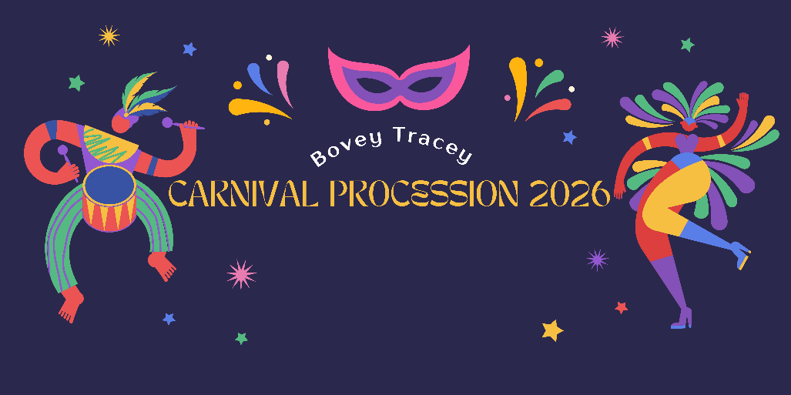
Carnival Procession Entry Form – Saturday 1st August 2026
Procession Categories and Prizes
Class | Description (Category) | 1ST | Runner Up
- Best Motorised Entry | This category is designed for motorised entry (Float/Trailer/Trade Vehicle Etc) | £50 | £20
- Best Costume Group (Walking) | This category is for groups dressed in costume walking (with or without sound vehicle) | £50 | £20
- Best Costume Individual (Walking) | This category is for a individual dressed up and walking (with or without sound vehicle) | £20 | £10
- Best Pram/Cycle/Similar | Best power assisted/push along pram/cycle or similar | £20 | £10

If you are unsure of which category to enter please get in touch.
 |  | ENTRIES MUST BE IN PLACE FOR JUDGING BY 5.00PM
Walkers outside The Bell / Dartmoor Whiskey Distillery. |  |  | Vehicles/floats to queue at Bradley Road

PLEASE RETURN ATTACHED SLIP AS SOON AS POSSIBLE TO
bookings@boveytraceycarnival.org.uk
---------------------------------------------------------------------------------------------------------------------------------------------------
NAME OF ENTRY:___________________________________________ CLASS #:__________________
NAME/ADDRESS:______________________________________________________________________________________
_________________________ PHONE NUMBER:_______________________________________
FLOAT/VEHCILE LENGTH APPROX:__________________________________
DO YOU HAVE MUSIC: Y / N
Please sign to show you agree to the Bovey Tracey Carnival Safety Guidelines
SIGN:_________________________________ DATE: ___________________________________

